Read me: Easy Micro Plot Extraction

This help guide is about the code EasyMPE\_main.py

Made by Tokyo University Field Phenomics Laboratory, 2018 - 2019

###### ENVIRONMENT #####

This code requires:

* Python (downloadable on Anaconda, tested on v. 3.6.8)
* Fiona (available on Anaconda, tested on v. 1.8.4)
* OpenCV package (available on Anaconda, tested on v. 3.4.3)
* pyQt package (available on Anaconda, tested on v. 5.9.2)
* scikit-image package (available on Anaconda, tested on v. 0.14.1)
* pyshp package (available on Anaconda, tested on v. 2.0.1)
* rasterio package (available on Anaconda, tested on v. 1.0.13)
* Fiona package (available on Anaconda, tested on v. 1.8.4)
* rasterstats package ; to install it, please refer to : <https://pythonhosted.org/rasterstats/installation.html> and use Anaconda Prompt (tested on v. 0.13.0)

###### BASE IMAGE REQUIREMENTS ######

Not every image is fitted to go through this code. The field image has to have grown vegetation i.e. the rows have to be visible but the rows should not touch each other much. It is best if the rows are homogeneous, that is to say there if the plants are sowed on a same line without moving aside from that row and approximately the same density. A few weeds are acceptable if not predominant and smaller than the rows.

Inputs can be both RGB or binary image. If the latter, please do not forget check the related box.

Examples of images that fit the requirements and the inputted parameters are in Annex 1.

###### GUI INPUTS ######

Once the GUI code is launched, several inputs will be asked.

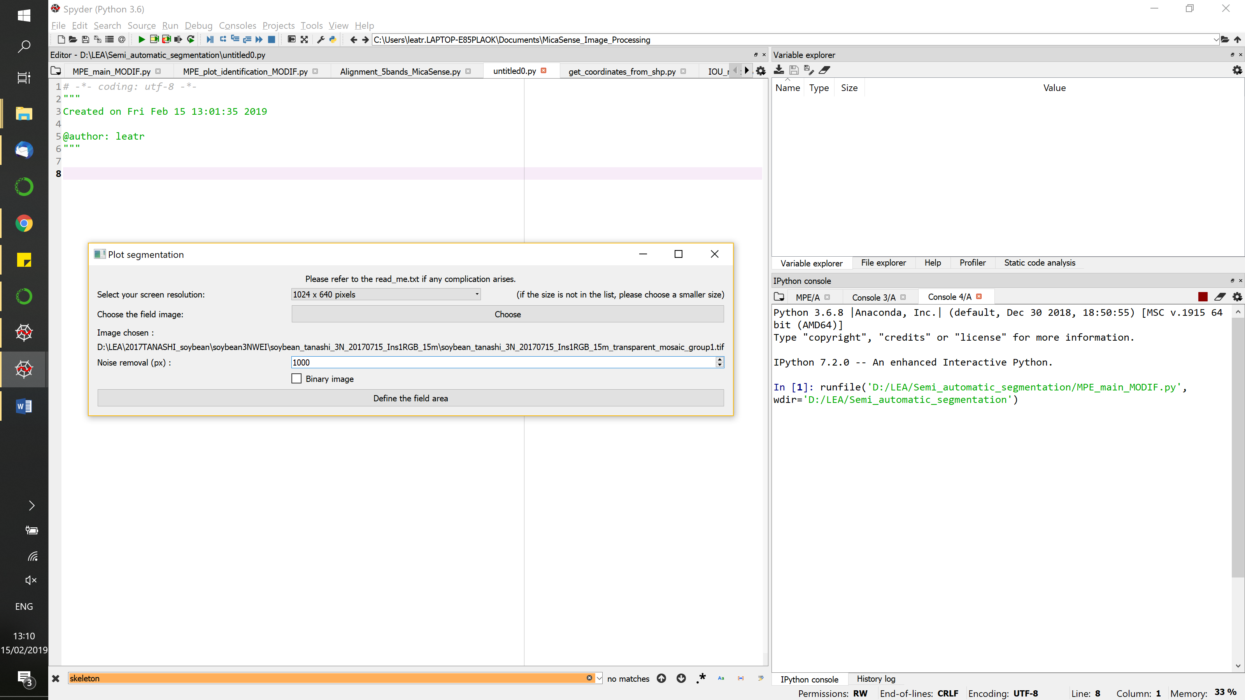

Select your screen resolution: as most field images are big pictures, they need to be resized so you can select the region of interest on your screen. If your screen resolution is not in the list, please choose a smaller size so that the whole image can be displayed.

Choose the field image: this is the image that will be processed. Once you chose one file, the path will be displayed under the button and the “Define the field area” button will be available. This image does not need to be cropped beforehand as you will draw your region of interest afterwards.

Noise removal (px): minimal size in pixels for objects to be kept during binarization. It aims at erasing the smaller weeds. The value depends of the image size and the average size of the rows. Please check the binary output after this step to make sure the noise input fits the image! If not, you can re-do this step after changing the noise value. This value is important as it is the only way the user can **influence** the image manipulation.

Binary image: if your input image (i.e. field image) is a binary file, check this box. Otherwise, do not. This option is handy if the user is not convinced by the binary image automatically calculated by the program (using Excess Green and Otsu threshold) or if some weeds need to be removed.

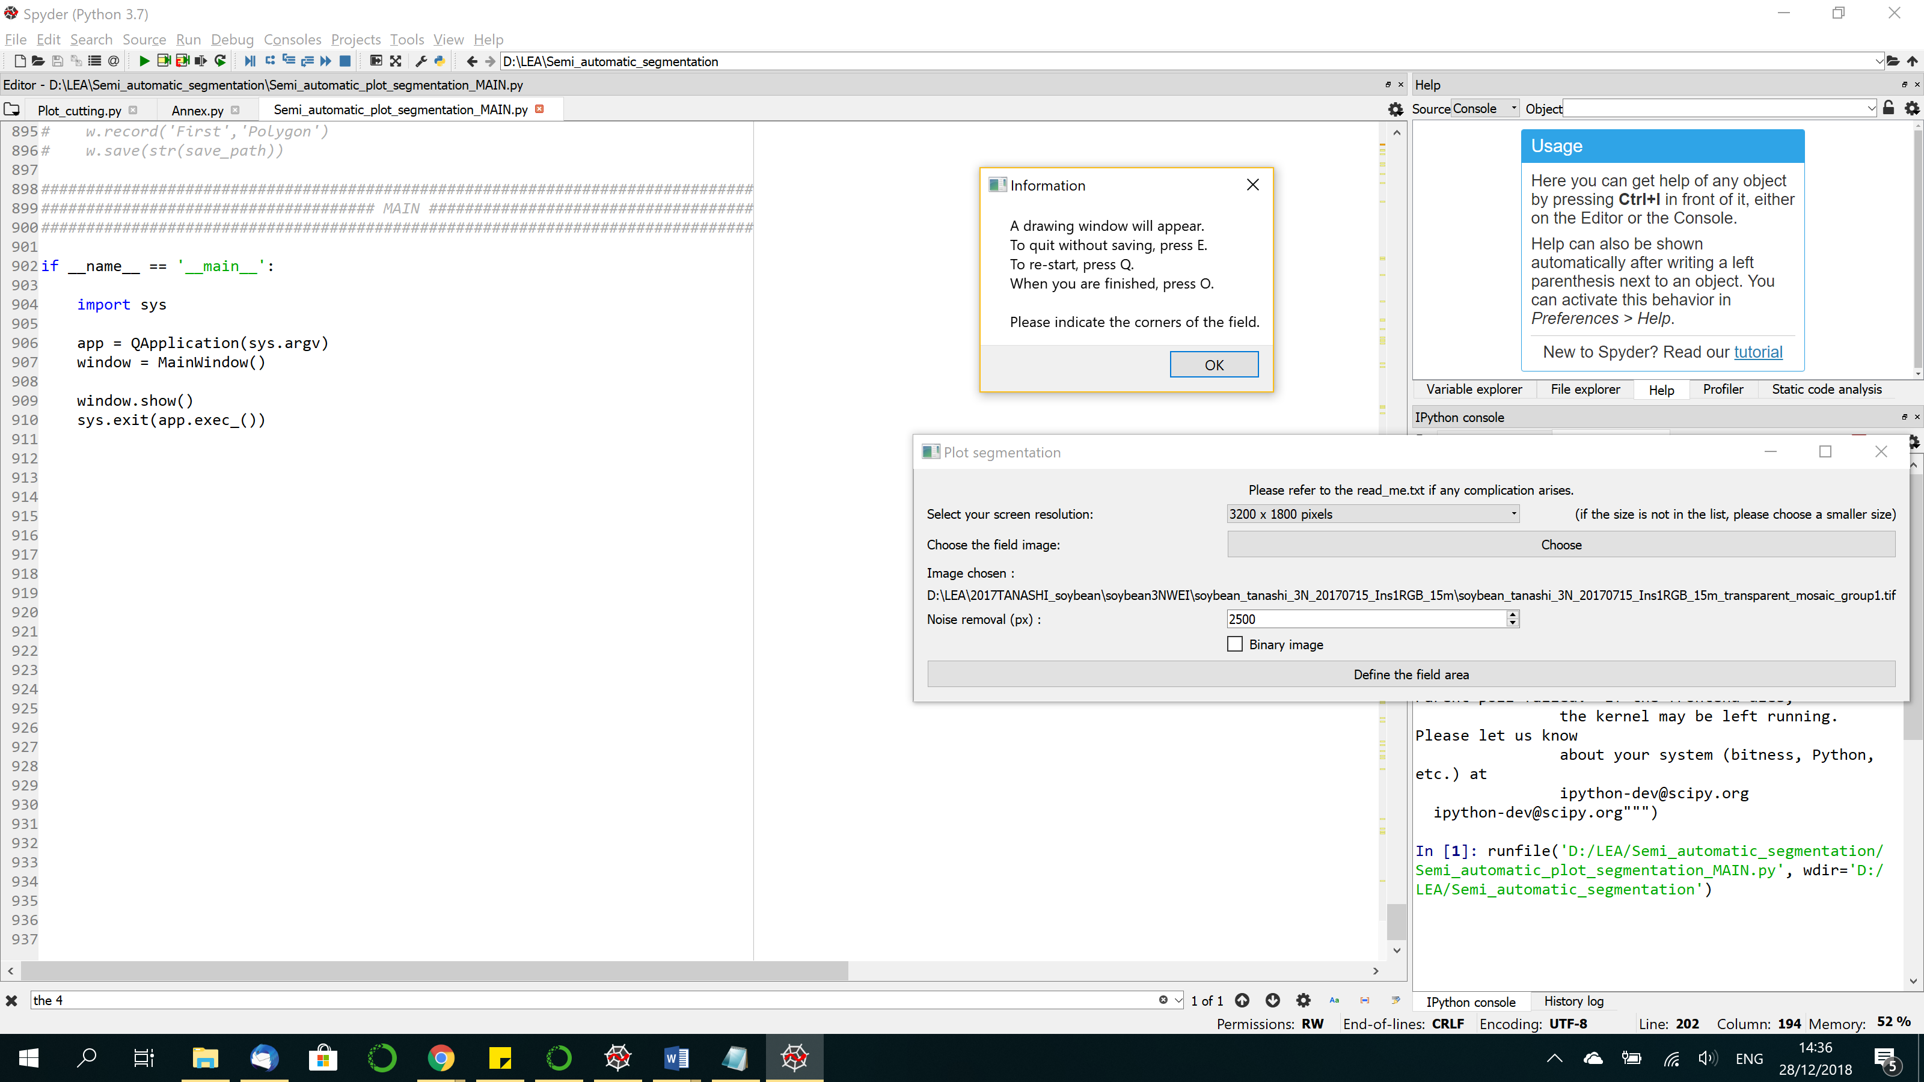Once everything is completed, the button 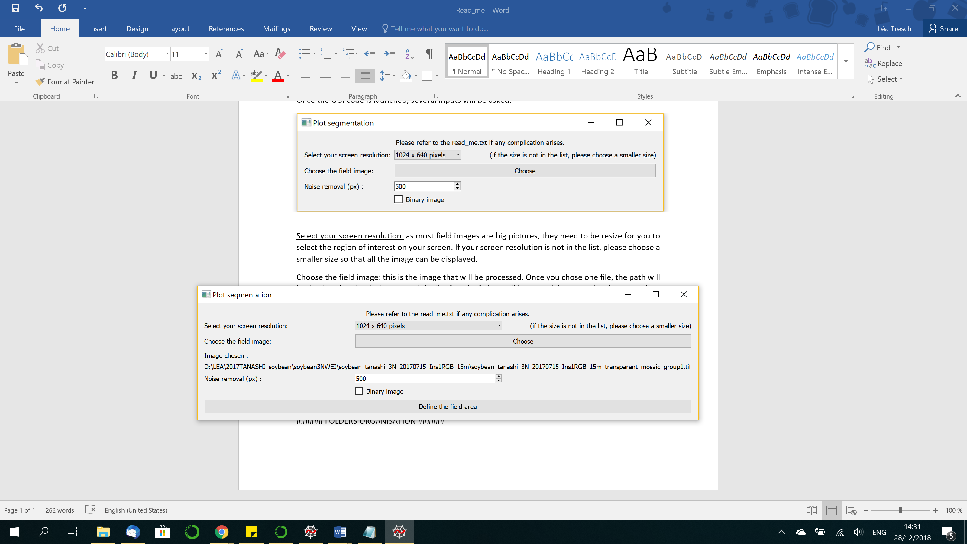 is available. Click on it. An informative window pops up.

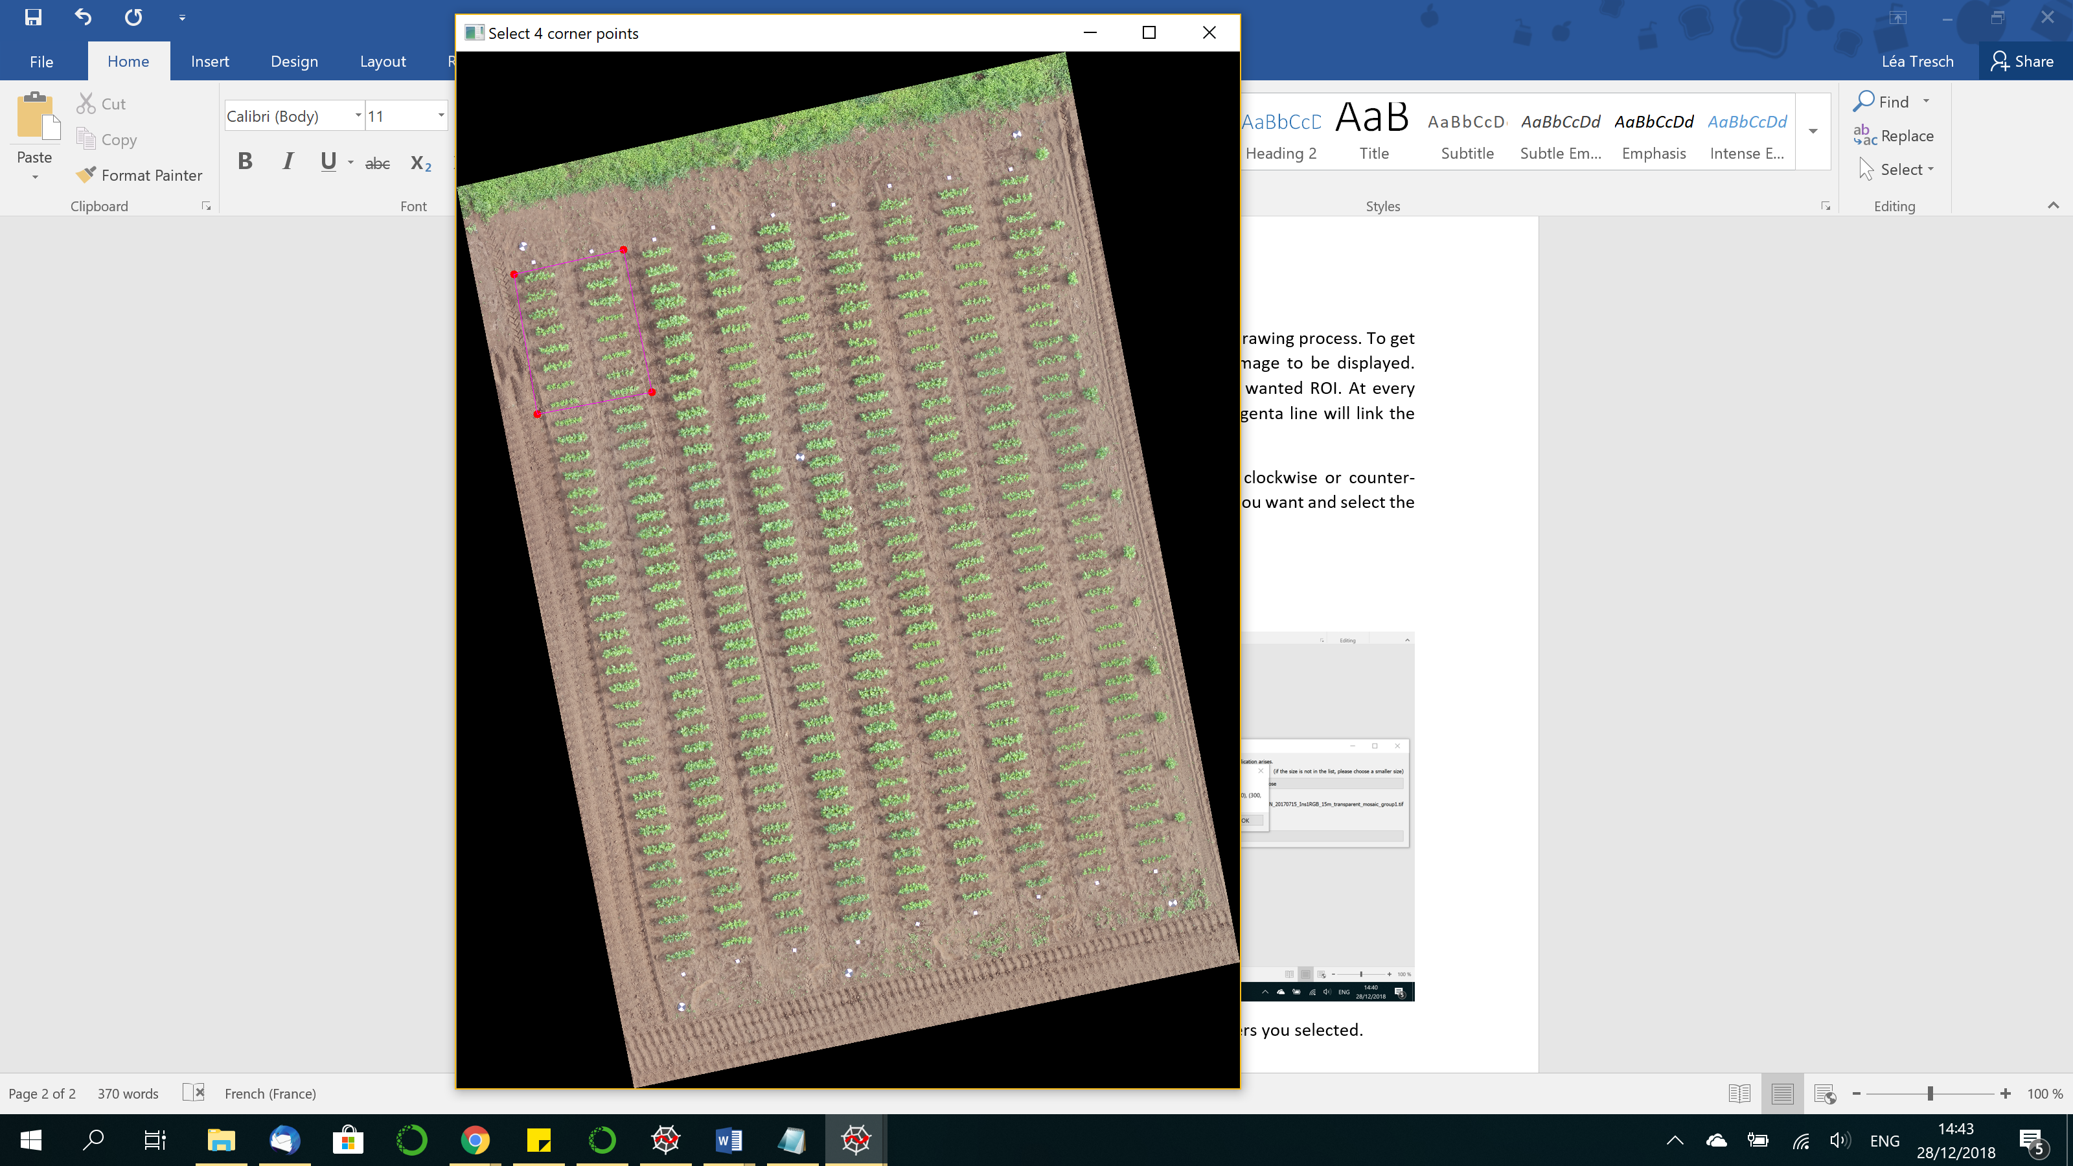It gives the instruction to go through the drawing process. To get started, click OK and wait for the field image to be displayed. Now, simply click on the corners of your wanted ROI. At every click, a red circle will be drawn and a magenta line will link the points. Press O to close the drawing (as showed on the right image)

Please point out the region logically i.e. all points clockwise or counter-clockwise. You can add as many points as you want and select the region you want. Everything outside the region will not be processed. Please make sure that the wanted rows are directly next to the selection, i.e. that there is no weed or ground check point that would be appear on the binary image around the plot. If there is, make sure to select a region closer to the rows.

After pressing O, another informative window will pop up, indicating the corners you selected. The binarization of the image is then starting, which takes a bit of time depending on the region’s size. You can redraw the region of interest as much as you want even after this step if it does not satisfy you or if you need to change the noise value.

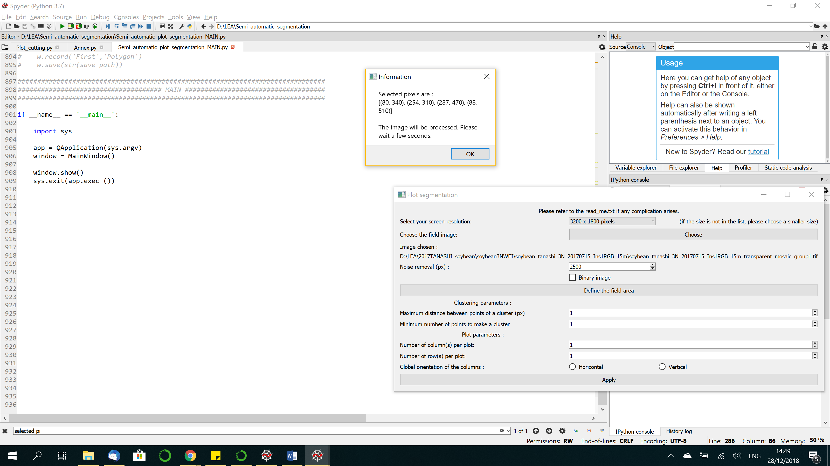

After this step, the main window changed to this:

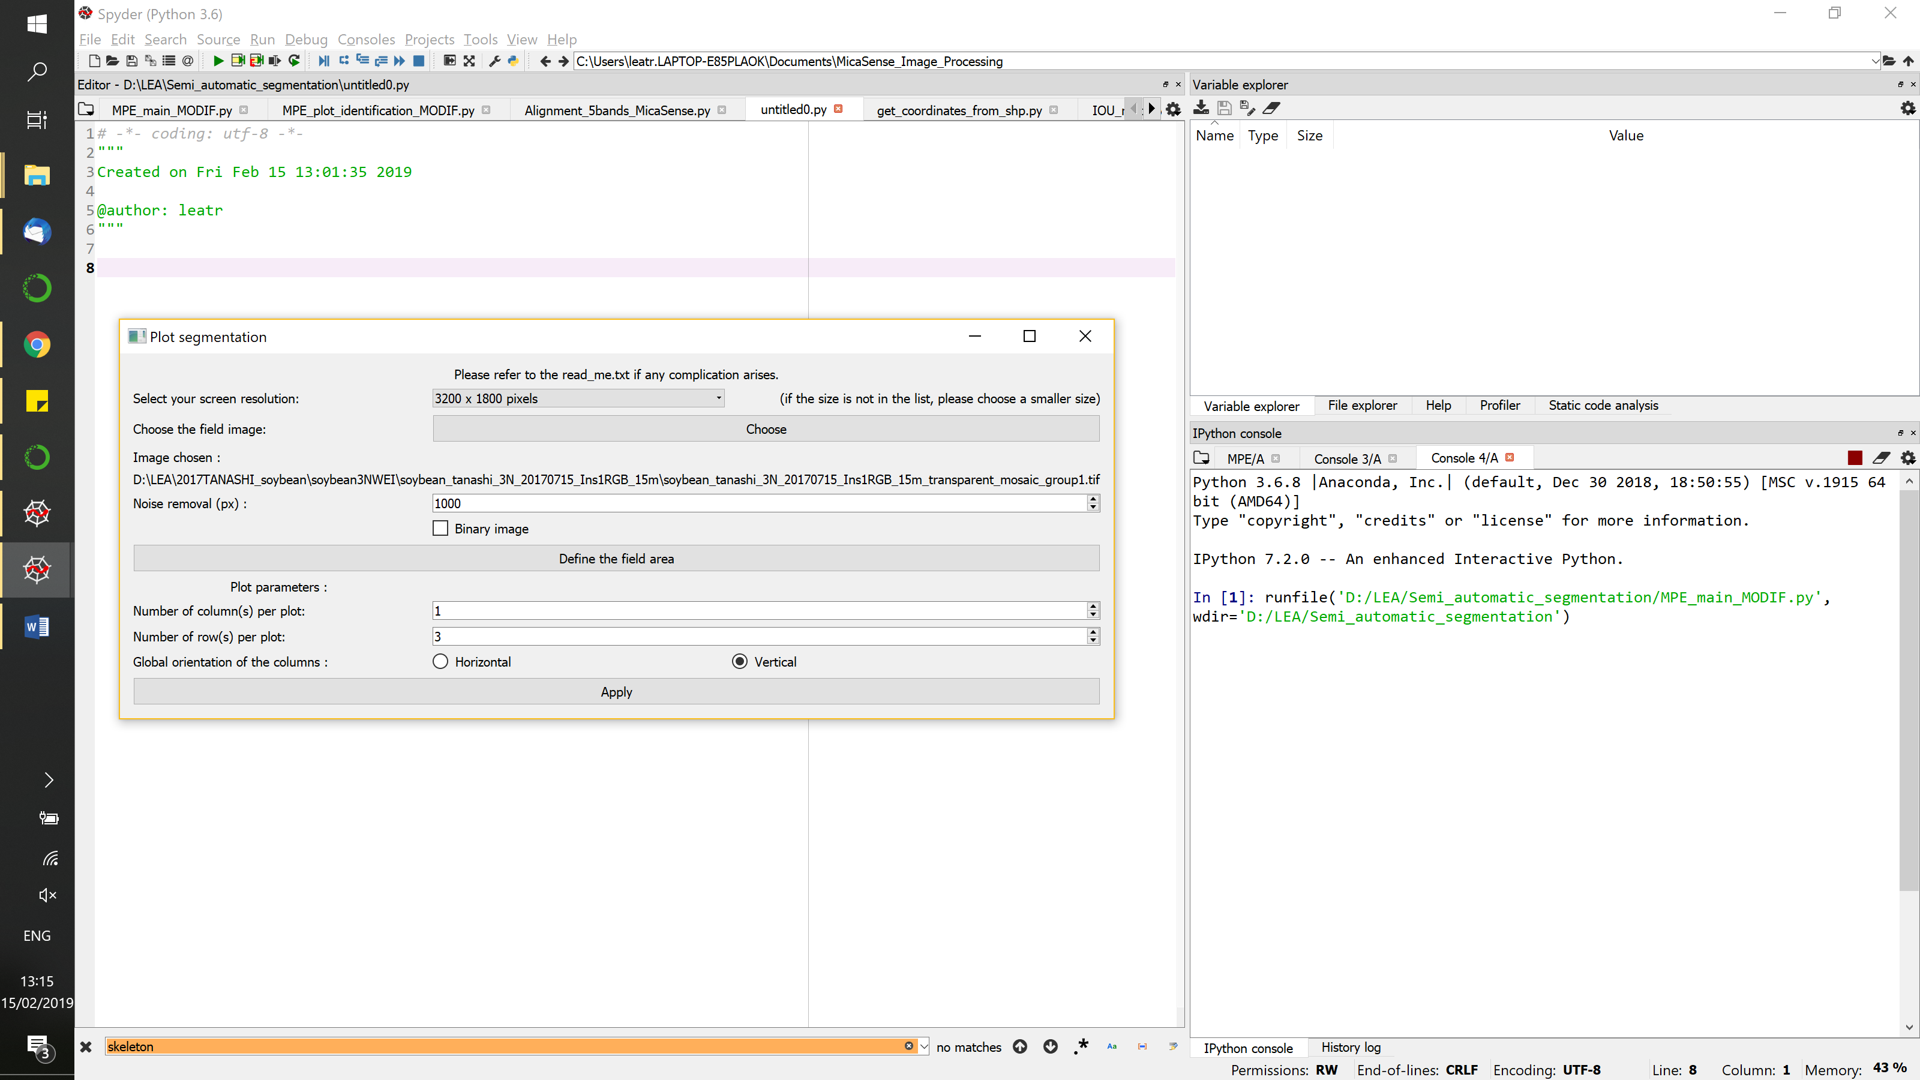

Plot parameters are already known by the user.

Number of columns(s) per plot: the number of column that are in a plot. Usually 1.

Number of row(s) per plot: the number of rows per plot. Usually more than 1, but can be 1.

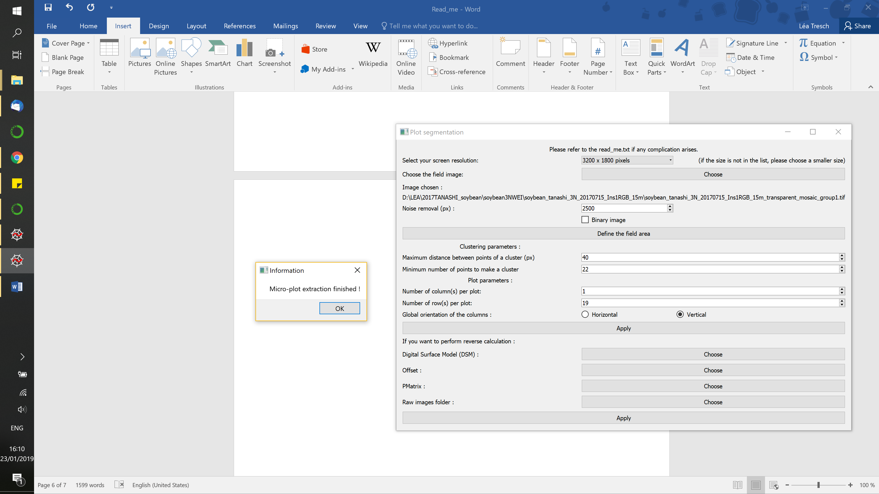Global orientation of the columns: either horizontal or vertical. If the orientation is in between, check the one that seems the most intuitive.

Then, click “apply”. Once the code ran, the window on the right will pop.

After clicking “OK”, you can start over with other parameters if needed. You do not need to re-define the region of interest if you want the same as before.

If your original field image is not georeferenced, this is the last step of the program. A pop-up window will inform you of that.

Otherwise, the main window changes again to be displayed as :

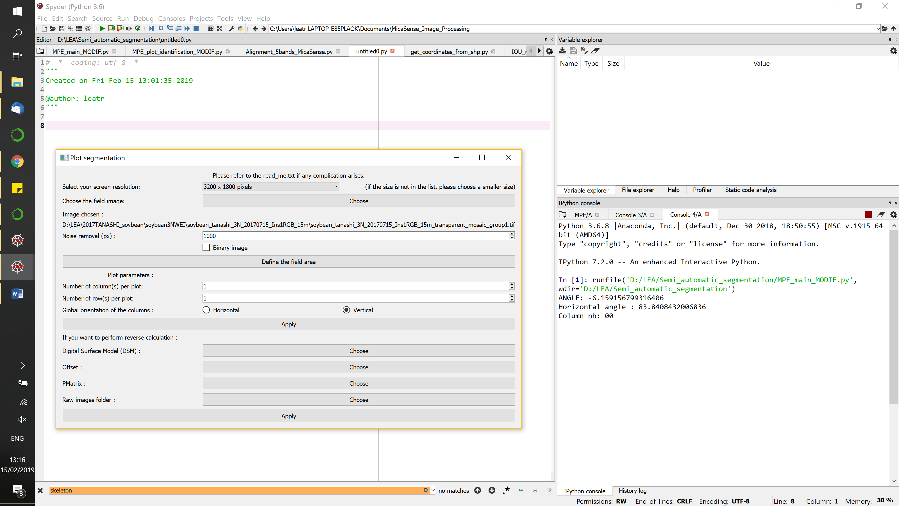

The last part is about reverse calculation. The goal and process is explained below in the “Reverse calculation” part.

Several inputs are needed here:

* a digital surface model (DSM) of the field image you chose in the first part ; it is a .tiff file
* the offset of the image ; it is either a .txt or a .xyz file
* PMatrix file of the translation of raw image into a whole image ; it is a .txt file
* the folder containing the raw images i.e. the direct drone images used to make the PMatrix and offset files

Once you inputted all the needed files, click “Apply”. The reverse calculation will be done quite quickly, depending on the number of raw images and plots.

After this, a pop-up window appears as displayed below. This is the end of the GUI. You can obviously redo as much as you want the different steps, as long as you have the right inputs.

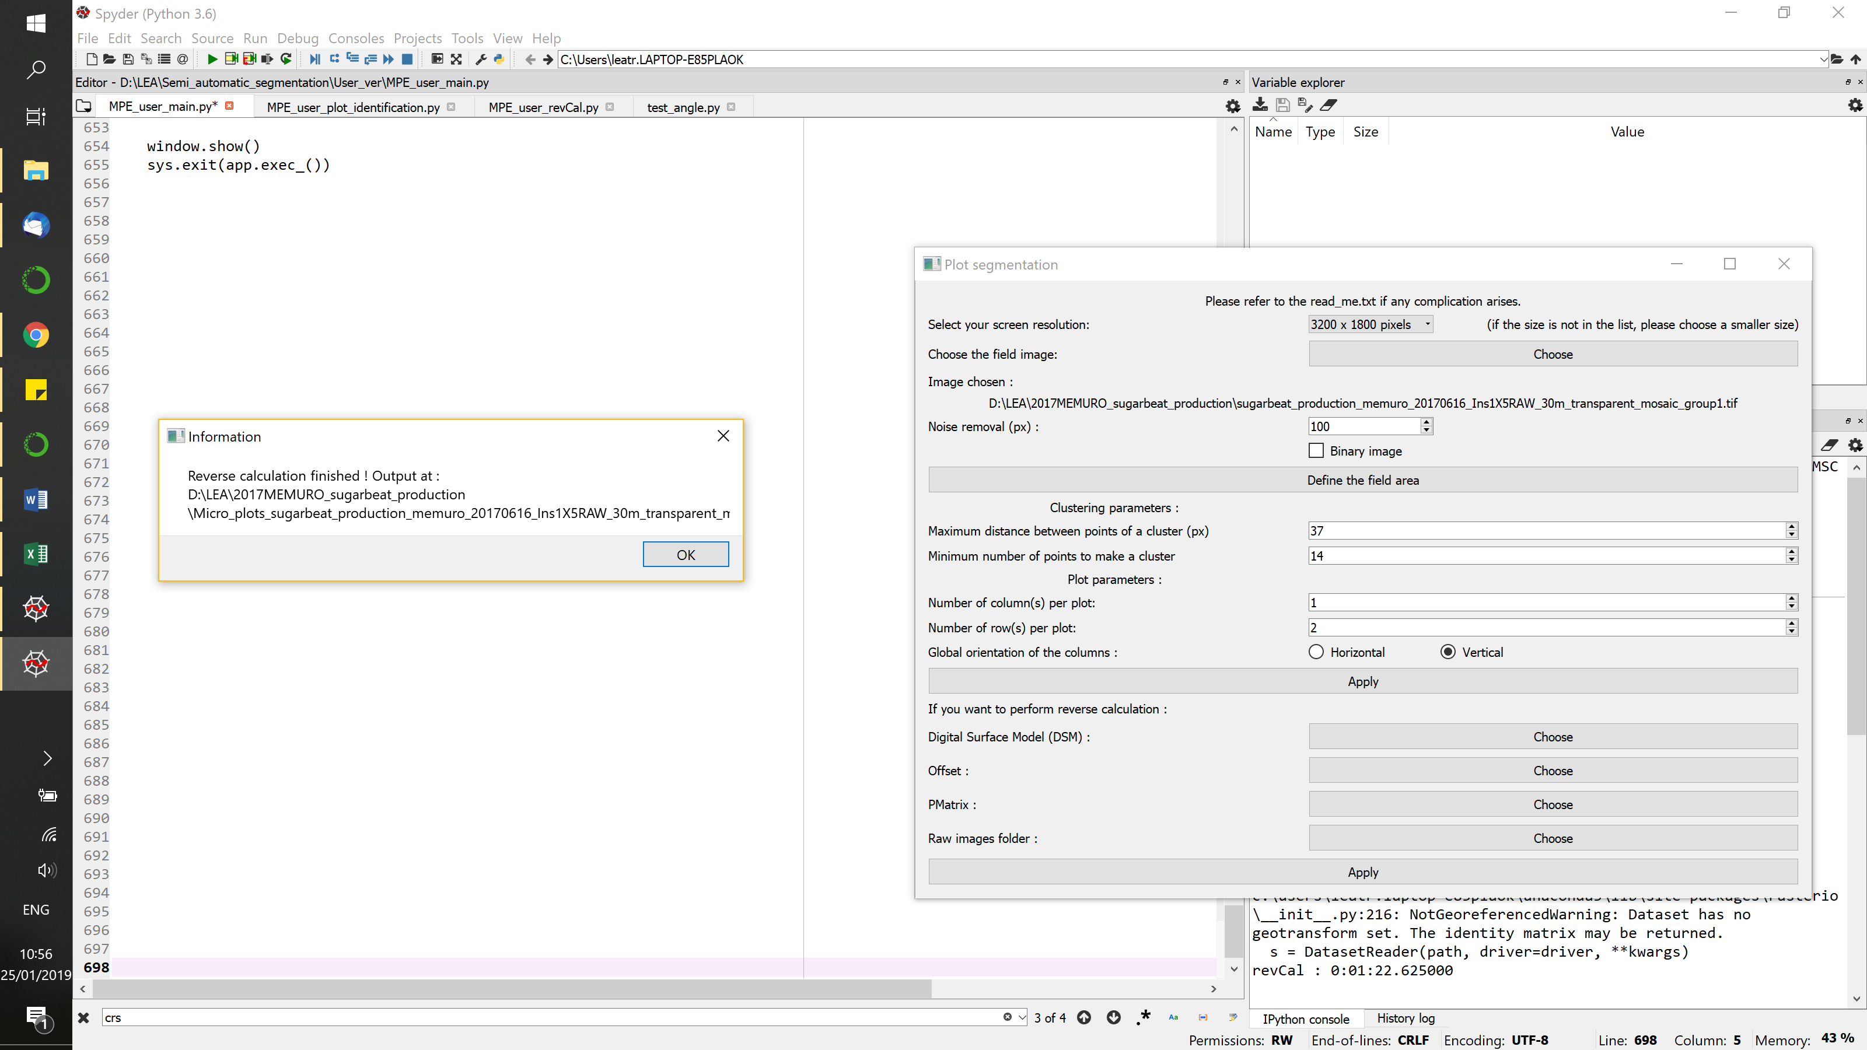

###### FOLDERS ORGANISATION ######

All the saved files are in the same repertory, which you can find in the folder of your field image. The repertory is called “Micro\_plots\_ORIGINALIMAGENAME”.

About the files:

* if the original file was georeferenced (i.e. GeoTIFF with a CRS), then the .\*shp files generated by the code are saved in the same coordinates system *Intersection\_points\_georeferenced.csv*
* If the original file was not georeferenced (i.e. \*.jpg, \*.png or unreferenced \*.tiff), the \*.shp files have the pixel coordinates of their regions on the original image in the file *Intersection\_points\_non\_georeferenced.csv*. The origin is in the upper left-hand corner of the image and the y-axis is oriented up (the image is in the negative area of y). The reverse calculation is not possible in this case. The \*.shp might also not be usable for other dates, depending on the image size compared to the inputted image.

The output files are as follows, in the folder “Micro\_plots\_ORIGINALIMAGENAME”:

* *All\_plots.shp* is the shapefile of all the individual plots. Individual shapefiles can be found in the folder “SHP\_files”.
* *Binary\_columns\_straight.jpg* is the binary image on which the vertical columns are clearly delimitated by vertical lines
* *Binary\_core.png* is the binary image of only the center of the columns (i.e. without possible inter-column weeds and without the end of each column)
* *Binary\_core\_columns.jpg* is the binary\_core image rotated so that the column are vertical
* *Binary\_image.tiff* is the binary version of the field area image, using Excess Green and Otsu threshold to discriminate between plants and background. The noise removal is applied here.
* *Binary\_straight.jpg* is the binary\_image rotated so that columns are vertical
* [if the inputted field image is not a binary image] *ExcessGreen.tiff* is the Excess Green version of the field image, used then to produce the binary image. The plant areas are supposed to be darker than the background. If it is not the case, it might be because the original image settings were not good for a binarization. In this case, please use a binary image as an input.
* [if the inputted field image is not a binary image] *Field\_area.tiff* is the original image cropped as delimitated by the user.
* *Field\_points.jpg* is the original image with the region of interest delimitations, as drawn by the user.
* [if the original image is georeferenced] *Intersection\_points\_georeferenced.csv:* \*.csv file containing the coordinates of each micro-plot according to the original image coordinate system
* *Intersection\_points\_non\_georeferenced.csv:* \*.csv file containing the pixel coordinates of each micro-plot in the images
* *Metadata.txt:* text file containing all the inputs, files paths and some calculated parameters
* [if the reverse calculation has been done] *Reverse\_cal\_outputs.csv:* \*.csv file containing the coordinates of each plot in the raw data images
* *Skeleton\_manipulated.jpg* is the image used to identify the columns; it has been manipulated so that each column is well defined and identifiable
* *Skeleton\_original.jpg* is the skeleton of the binary image without any modification

As for the output folders:

* *Horizontal\_columns*: \*.jpg files of the identified columns, rotated to be horizontal, based on the Plot\_columns\_all\_clusters images. These files are used to identify the rows.
* *Plot\_columns\_binary:* \*.jpg files of the identified columns, cropped, in the binary image
* *Plot\_columns\_core:* \*.jpg files of the center area of the identified columns, cropped, in the binary image
* [If the original picture is not a binary] *Plot\_columns\_original:* \*.jpg files of the cropped identified columns, here based on the inputted field image [RGB]
* *Plot\_rows\_binary:* \*.jpg files of the microplots cut out from the binary image and not resized, i.e. with black background
* [If the original picture is not binary] *Plot\_rows\_original:* \*.jpg files of the identified micro-plots, here cut out from the original image [RGB] and resized to fit the plot size
* [If the original image is not binary] *Plot\_rows\_original\_whole:* \*.jpg files of the identified micro-plots, here cut out from the original image [RGB] and not resized, i.e with black background
* *SHP\_files:* \*.shp files and annex files (\*.dbf, \*.shx) of the identified micro-plots

**###### IF THE CODE IS NOT WORKING ######**

If the rotation of the image is not good, please re-select your region of interest closer to the plot. If you look at the binary image, there might be something that prevent the bounding box, generated by the code to get the angle of the field, to stick to the rows.

If the columns are not well identified, it is probably because of the weeds. You can provide a weed-free binary image if you know of any weed discriminator program, or even do it quickly by hand by erasing the biggest weeds. No need for the field to be strictly weed-free.

A field on which the code is not working is displayed in Annex 2 as an example.

**###### REVERSE CALCULATION ######**

Reverse calculation’s goal is to find the pixels associated with each plot in each original images, i.e. go back up from the orthomosaic to the raw drone image. This allows to avoid a diminution in the pictures’ quality. For example, the reverse calculation provides a more precise estimate of ground cover compared with the orthomosaic[[1]](#footnote-1).

Here are the equations used to do the reverse calculation for a camera without distortion, using Pix4D mapper[[2]](#footnote-2) outputs[[3]](#footnote-3):

(1)

(2)

(3)

With: (x, y, z) intermediate coordinates

(X, Y, Z) the coordinates of the 3D point cloud (already offset-corrected)

(u, v) the coordinates of the plot in the raw image

PMat the transformation matrix

The code has been build using Pix4D outputs, but using another free software can be imagined.

**ANNEX 1**: example fields

D:\LEA\2017MEMURO_sugarbeat_hybrid\SAVED_Field_manip_sugarbeat_hybrid_memuro_20170531_Ins1X5Raw_30m_transparent_mosaic_group1\Field_area.tiff

Sugar beet [1 month after sowing]

Parameters:

Noise: 500

Orientation: vertical

Soybean  
[approx. 1 month after sowing]

Parameters:

Noise: 200

Orientation: horizontal

D:\LEA\2018MEMURO_sugarbeat_field1\Mask\Binary_image.tiff

Sugar beet [1 month after sowing]

Parameters:

Noise: 100

Orientation: vertical



Sugar beet [1 month after sowing]

Parameters:

Noise: 500

Orientation: vertical



Sugar beet [1 month after sowing]

Parameters:

Noise: 100

Orientation: vertical



Soybean [1 month after sowing]

Parameters:

Noise: 1000

Orientation: vertical

**ANNEX 2:** field with too many weeds for the program to work

Whole crop image

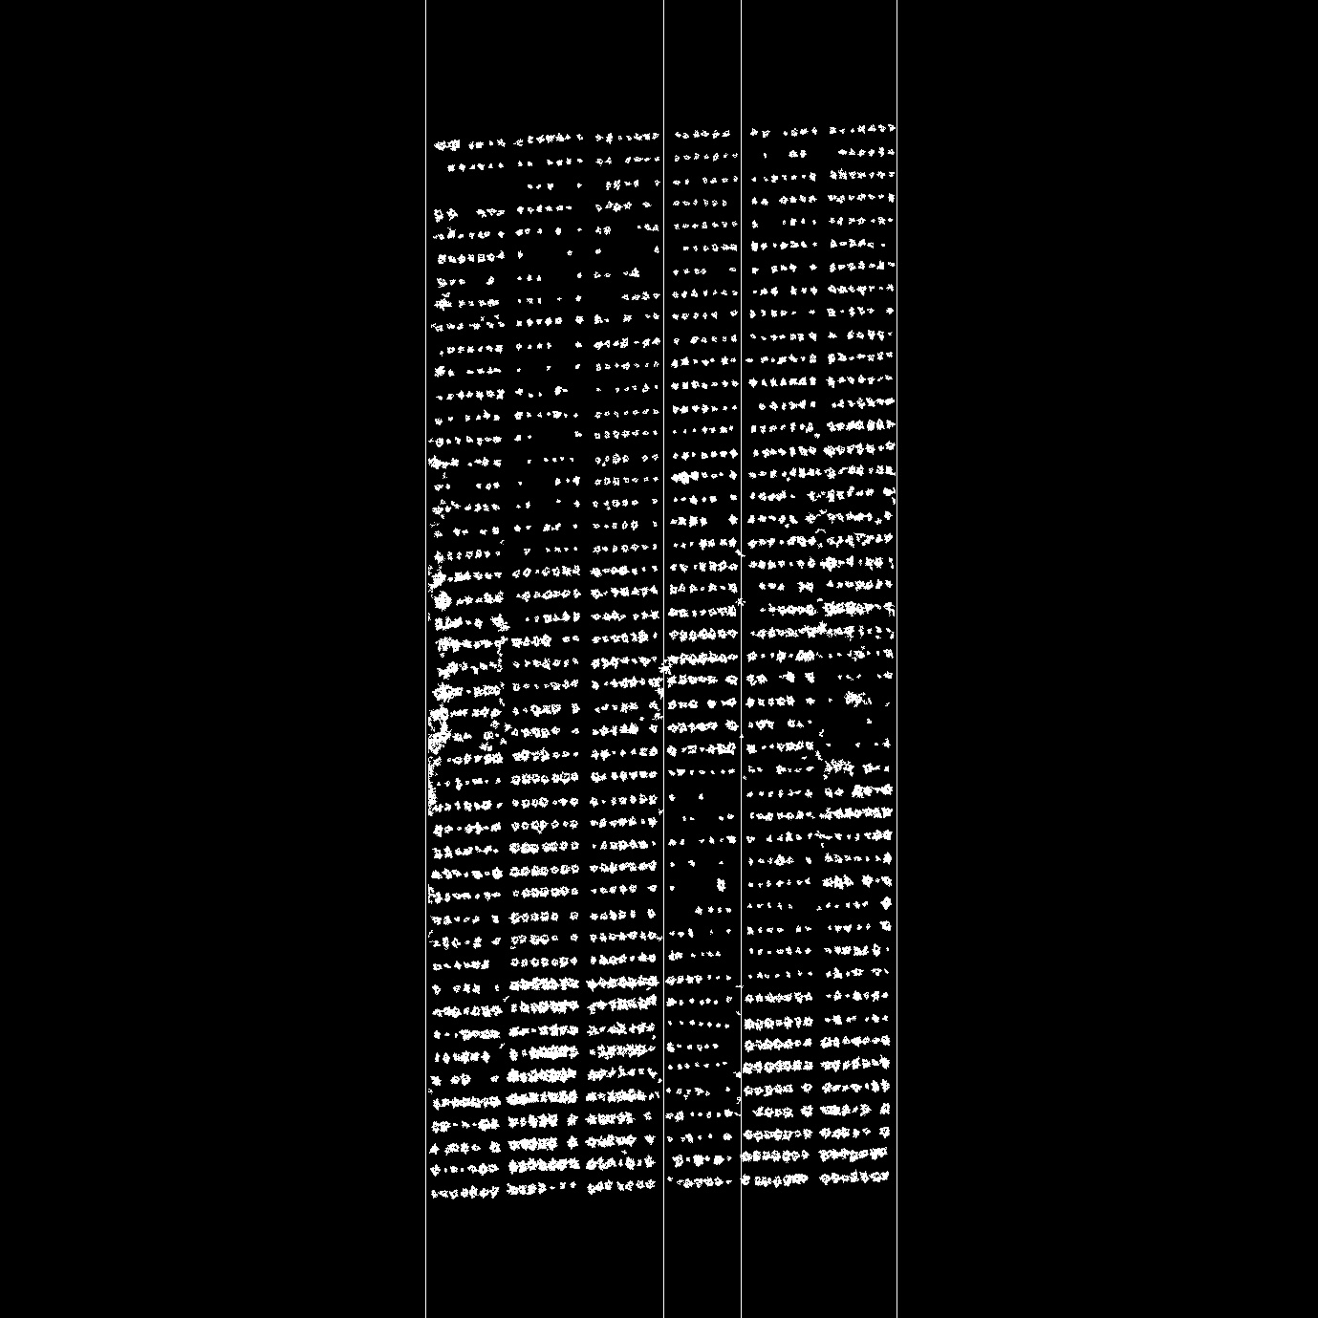

Column identification: notice that the two columns on the left are considered as one because of inter-column and overall weed presence

1. Duan T., Zheng B., Guo W., Ninomiya S., Guo Y. and Chapman S. C. (2016)*,* Comparison of ground cover estimates from experiment plots in cotton, sorghum and sugarcane based on images and ortho-mosaics captured by UAV, *Functional Plant Biology 44(1)* 169-183. <https://doi.org/10.1071/FP16123> [↑](#footnote-ref-1)
2. Pix4D S.A., Lausanne (Switzerland), <https://www.pix4d.com/> [↑](#footnote-ref-2)
3. Pix4D Support, *What does the Output Params Folder contain?* Available at: <https://support.pix4d.com/hc/en-us/articles/202977149-What-does-the-Output-Params-Folder-contain-#label12> [↑](#footnote-ref-3)